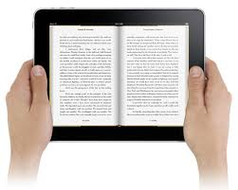
Access GCPS eBooks and audiobooks from your smartphone, tablet, and computer.

Read an eBook today!
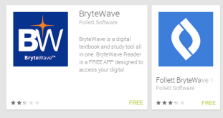
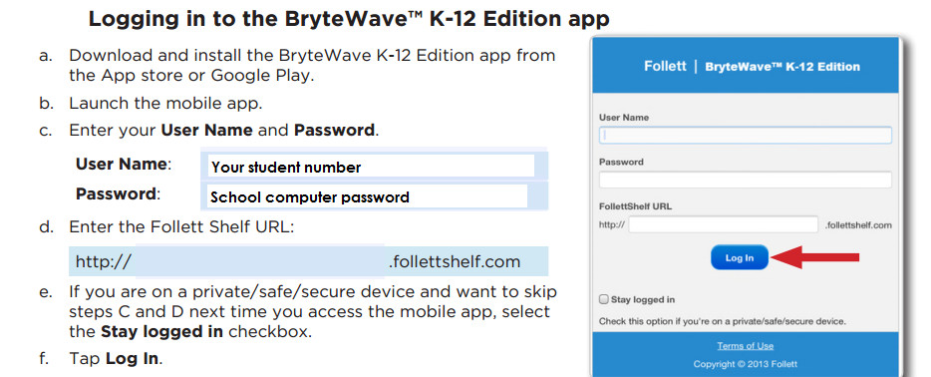
________________________________________
wbb14051
Case sensitive!
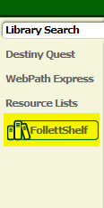
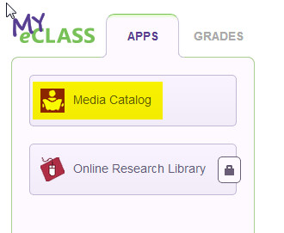
Access eBooks Using a Computer

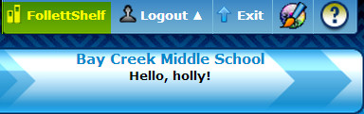

Log into the student portal (My eCLASS) and click on Media Catalog in the Apps section. Log into the Media Catalog using your school number and password. Then click on the FollettShelf link.
You can also access the FollettShelf using the direct URL. Don’t forget to log in!
http://wbb14051.follettshelf.com

