How to Access the GCPS Research Databases and the Online Catalog
When You’re Not at School

- Go the GCPS website at www.gwinnett.k12.ga.us.
- Click on the words My eClass located towards the top of the screen.

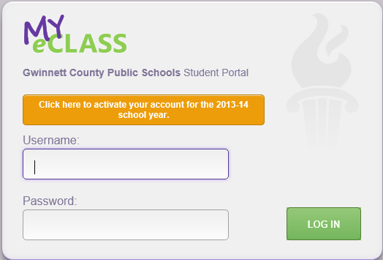
- The username is your student ID number. The password is the password the student uses to log onto computers at school.

- Click on the words Online Research Library to see a list of the research databases available.
- Click on the words Media Catalog to search for library books located in the RMS media center

