How to check your Destiny library media account

- Click on the Media Catalog 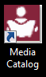 icon

- Log into Destiny Quest
  - Click on 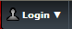
  - Username is your student number
  - Password is your RMS computer password

- Click on My Info 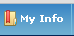

- Click on the My Checkouts tab 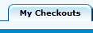 and you will see a list of items and due dates if you have library materials checked out to you.

