How to locate reliable resources using Mackin Via

GCPS provides numerous academic research databases for students. In order to access this wealth of information please follow the steps below.
- Click on the Online Research Library icon on your desktop.

- Click on the group of databases that will most likely contain information on your topic.
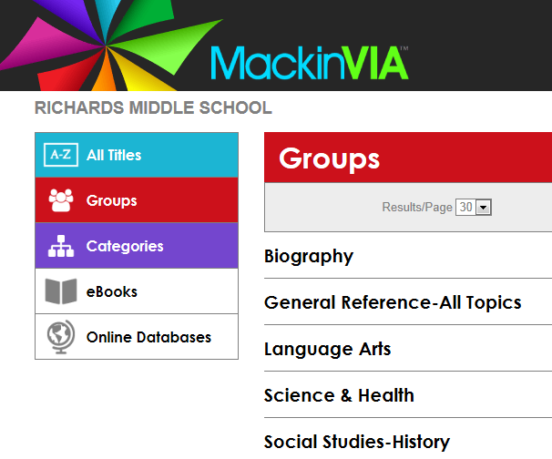

- For example, if you click on the words Language Arts you will see the following and a whole lot more!
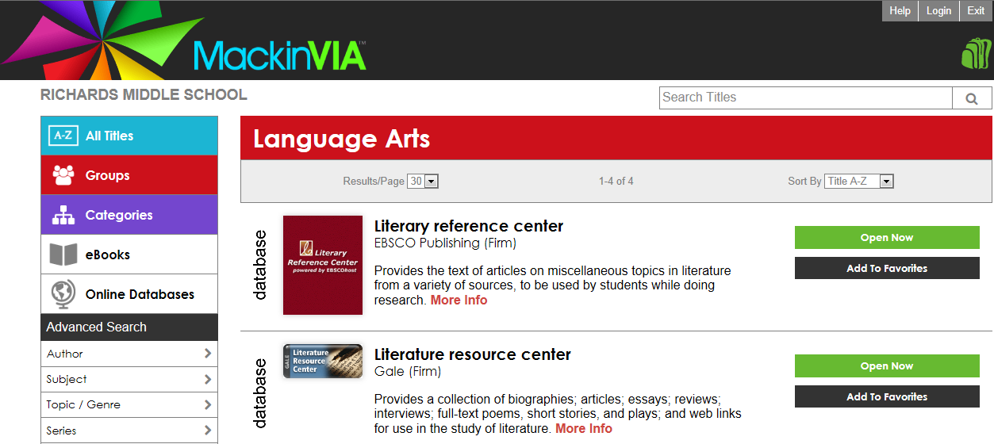

- Once you have selected a group, choose a database by clicking on the words and begin searching for information.

