How to See the Grade Level & Lexile Level for Online Articles found on Classic Destiny Media Catalog
- Click on the Media Catalog icon on your desktop.

- Click on Webpath Express located on the left side of the screen.
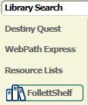

- Type your topic in the search box and press enter.

- A list of websites/articles will appear.
